Camp Copenhagen 2019 - General information

When? The dates for Camp Copenhagen are from Saturday, August 10th to Saturday, August 24th
with arrivals and departures on the 10th and 24th respectively.

Where? Participants will stay at a scout’s cottage like previous years. It is located 20 kilometers north of Copenhagen, in an area called Naerum. This means that shopping, cooking, dishwashing and keeping the place tidy will be part of the daily program (teamwork) in addition to the activities listed under “What?” All participants will sleep in the same dormitory, and the accommodation will be simple cottage style, however all appliances are available.
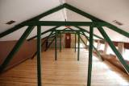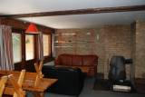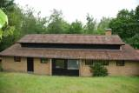

Who? The camp accepts 20 foreign participants aged 21-25 (in august 2019).
We accept a maximum of two participants - preferably one of each gender - from each country. All communication is in English (mandatory), which is the official language of the camp. Good English skills are important!! Participants must not have taken part in more than one Rotary camp prior, and must be sponsored by a Rotary club in their own country. Health insurance, visa etc. are the entire responsibility of the participants.

How? You will organize and pay for your own travel arrangements to and from Copenhagen. We kindly ask you to consider arrival and departure times to be reasonable, meaning not between 12 am and 6 am. Please advise our travel coordinator Ms. Lone Ricks – info@travelart.dk about your travel arrangements. Lone can be helpful when you are planning your travel. During your stay, following will be provided: Accommodation, necessary food, transport, and entrance fees. You must bring your own sleeping bag.

Check out the facebook group Camp Copenhagen 2018 – Ask earlier participants for info etc.
-> https://www.facebook.com/groups/833220443410758/

Fee The participation fee is only DKK 1500 (Danish Crowns) equivalent to 200 Euro, on your arrival. We recommended bringing about DKK 1000-1500 as allowance.
Remember that the Danish currency is Danish Kroner.

What? The program of the camp is focused on two important features of Scandinavian society and tradition: Environment and Democracy.
As for environment, you will experience the Danish nature, and we will show you how we try to protect our environment.
Our democracy part will, further to political democracy, focus on democracy at work, in education and in taking care of those in need.
We will organise guided tours around Copenhagen with a “time travel” from the buildings raised in the 16th century up to the present, with the Danish designed and sustainable low energy buildings focusing on building requirements. The world known architect Bjarke Ingels Group – BIG will be part of one of our programs.

We will show and tell you a lot, and we hope for your own involvement and inspiration during your visit. We also want you to tell us what is important to you in your own countries - This is the program of “The peoples’ day”.

A full day tour to the world known LEGOLAND is in the making and will be included in the program.

Visits to Danish cultural sights including the Little Mermaid, one or more castles, one of our amusement parks, along with visits to the hosting Rotary clubs is also part of the interesting program.

Program Saturday 10 Arrivals
Sunday 11 This is Denmark / The peoples’ day
Monday 12 Focus of today's visit: COPENHAGEN
Tuesday 13 Full day tour to LEGOLAND in Jutland
Wednesday 14 Focus of today's visit: ENVIRONMENT Day 1
Thursday 15 Focus of today's visit: DEMOCRACY Day 1
Friday 16 Tivoli
Saturday 17 Trip to Northern Sealand
Sunday 18 My Copenhagen / Nature day
Monday 19 Focus of today's visits: DEMOCRACY Day 2
Tuesday 20 Focus on today's visits: ENVIRONMENT Day 2
Wednesday 21 Architecture – The past and the present
Thursday 22 Project day
Friday 23 Evaluation and farewell arrangement
Saturday 24 Departures

**This is a provisional program and subject to change ***

As you can see, we have planned a tight program with lots of input. Throughout your stay, you will get in touch with local rotary members.

The life of a Rotarian is all about making an effort. The reward, through sincerity and commitments, is gratitude and widening of our horizons and meeting new challenges.
If Camp Copenhagen 2019 - The Scandinavian Way – Environment, Democracy & Architecture sounds interesting?
Then go for it! Send your application to Camp Copenhagen 2019 => cm-st@rotary-yep.net
Deadline for Application is April 1st, 2019 – Participants will be accepted upon receipt and review of application. Only two participants from each country can be accepted.

Additional information on Camp Copenhagen 2019 from camp coordinator Torben Nygaard on e-mail torben.nygaard@fctg.dk or phone => or phone +45 20182424
…………………………………………………Team CAMP CPH look forward to welcome you !.............................
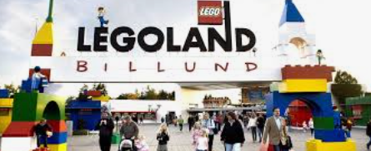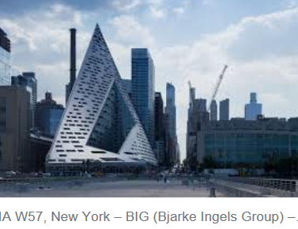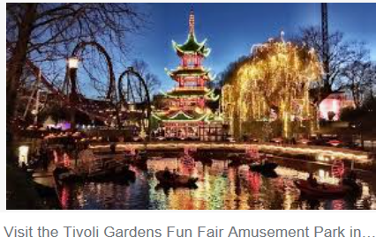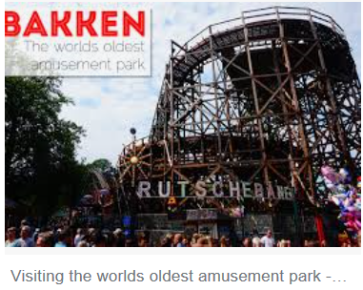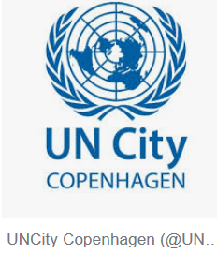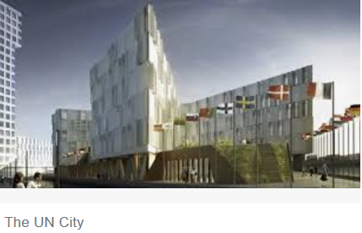
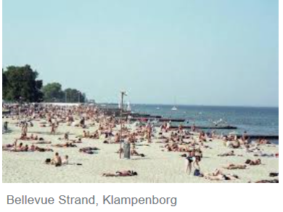…….. take a bike ride to the beach… 😊… 